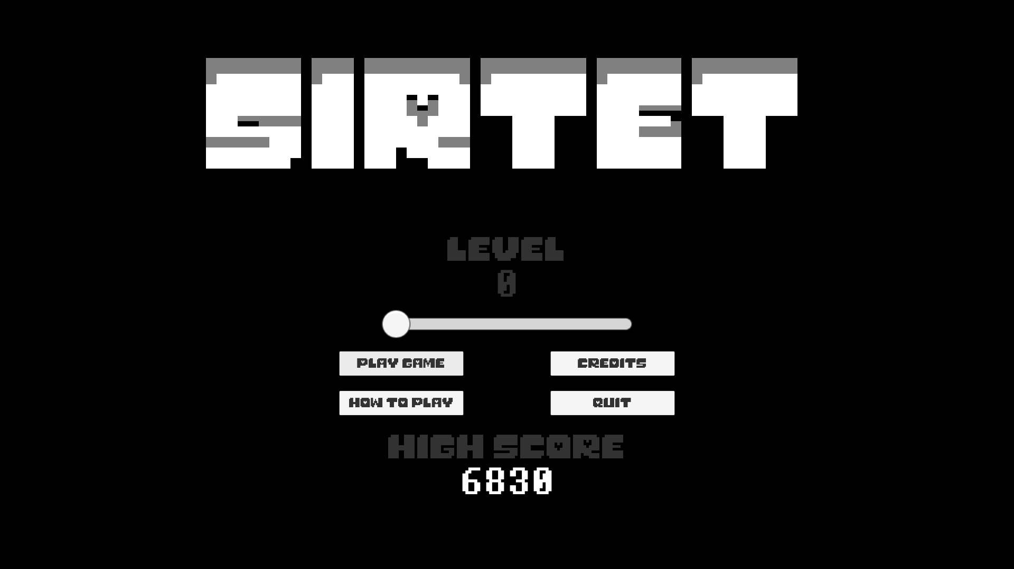

**Game Design Document**

**Table of Contents**

|  |  |  |
| --- | --- | --- |
| [1 Game Overview](https://n-xovwktmtjsnaxyc2mwes2xu7pohqedmdm6zjw5q-2lu-script.googleusercontent.com/userCodeAppPanel)  [2 High Concept](https://n-xovwktmtjsnaxyc2mwes2xu7pohqedmdm6zjw5q-2lu-script.googleusercontent.com/userCodeAppPanel)  [3 Synopsis](https://n-xovwktmtjsnaxyc2mwes2xu7pohqedmdm6zjw5q-2lu-script.googleusercontent.com/userCodeAppPanel)  [4 Game Objectives](https://n-xovwktmtjsnaxyc2mwes2xu7pohqedmdm6zjw5q-2lu-script.googleusercontent.com/userCodeAppPanel)  [5 Game Rules](https://n-xovwktmtjsnaxyc2mwes2xu7pohqedmdm6zjw5q-2lu-script.googleusercontent.com/userCodeAppPanel)  [6 Game Play](https://n-xovwktmtjsnaxyc2mwes2xu7pohqedmdm6zjw5q-2lu-script.googleusercontent.com/userCodeAppPanel)  [6.1 Game Controls](https://n-xovwktmtjsnaxyc2mwes2xu7pohqedmdm6zjw5q-2lu-script.googleusercontent.com/userCodeAppPanel) (PC)  [6.2 HUD](https://n-xovwktmtjsnaxyc2mwes2xu7pohqedmdm6zjw5q-2lu-script.googleusercontent.com/userCodeAppPanel)  [7 Players](https://n-xovwktmtjsnaxyc2mwes2xu7pohqedmdm6zjw5q-2lu-script.googleusercontent.com/userCodeAppPanel)  [7.1 Characters](https://n-xovwktmtjsnaxyc2mwes2xu7pohqedmdm6zjw5q-2lu-script.googleusercontent.com/userCodeAppPanel)  [7.2 Metrics](https://n-xovwktmtjsnaxyc2mwes2xu7pohqedmdm6zjw5q-2lu-script.googleusercontent.com/userCodeAppPanel)  [7.3 States](https://n-xovwktmtjsnaxyc2mwes2xu7pohqedmdm6zjw5q-2lu-script.googleusercontent.com/userCodeAppPanel)  [7.4 Weapons](https://n-xovwktmtjsnaxyc2mwes2xu7pohqedmdm6zjw5q-2lu-script.googleusercontent.com/userCodeAppPanel)  [8 Art](https://n-xovwktmtjsnaxyc2mwes2xu7pohqedmdm6zjw5q-2lu-script.googleusercontent.com/userCodeAppPanel)  [8.1 Setting](https://n-xovwktmtjsnaxyc2mwes2xu7pohqedmdm6zjw5q-2lu-script.googleusercontent.com/userCodeAppPanel)  [8.2 Level Design](https://n-xovwktmtjsnaxyc2mwes2xu7pohqedmdm6zjw5q-2lu-script.googleusercontent.com/userCodeAppPanel)  [8.3 Audio](https://n-xovwktmtjsnaxyc2mwes2xu7pohqedmdm6zjw5q-2lu-script.googleusercontent.com/userCodeAppPanel)  9 What you Developed  10 Credits  11 Development Log   |  | | --- | |  | | **GAME DEVELOPMENT**  **TEAM MEMBERS**    PRODUCER  AC De Leon    PRODUCTION MANAGER  AC De Leon    PRODUCTION COORDINATOR  AC De Leon  GAME DESIGNERS  AC De Leon  SYSTEMS/IT COORDINATOR  AC De Leon  PROGRAMMERS  AC De Leon  TECHNICAL ARTISTS  AC De Leon  AUDIO ENGINEERS  AC De Leon  UX TESTERS  AC De Leon |

|  |
| --- |
|  |

# Game Overview

**Title:** Sirtet

**Platform:** PC Standalone

**Genre:** Tile-matching Puzzle

**Rating:** (10+) ESRB

**Target:** Casual gamer (aging from 12 - 30)

**Release date:** November, 2017

**Publisher:** acfromspace

Sirtet is a tile-matching puzzle game where the player puts together puzzle pieces to get horizontal lines to obtain points. Be warned though! The screen is warped thus affecting the player’s ability to put the puzzle pieces in the correct locations. The game is over when the puzzle pieces reach above the playing field. A friendly skeleton is also found in the game to accompany you in your efforts to achieve a high score.

# High Concept

Sirtet sets the player in a puzzle piece game where they must work against time in order to achieve a high score. As the player scores more points through horizontal lines, the speed of the game increases. Think fast and place those puzzle pieces correctly to survive longer!

# Synopsis

You are a Player playing a tile-matching puzzle game with a warped screen.

# Game Objectives

The objective of the game is to survive for as long as possible while creating horizontal lines with the puzzle pieces.

# Game Rules

The game level is a closed environment set in the abyss of just black where the Player is attacked with puzzle pieces that they must stack in the play area. The Player can move around left, right, down, rotate, the puzzle pieces around until it reaches the bottom when another puzzle piece spawns towards the top. The puzzle pieces that spawn are random and will try to defeat the Player (along with the time). The Player scores points by creating horizontal lines, the number points earned depends on the time taken to put a piece down and the amount of lines cleared at any given time. After creating a certain amount of lines, the level increases along with difficulty through faster speed of the puzzle pieces till eventually the Player loses or quits.

# Game Play

## Game Controls (PC)

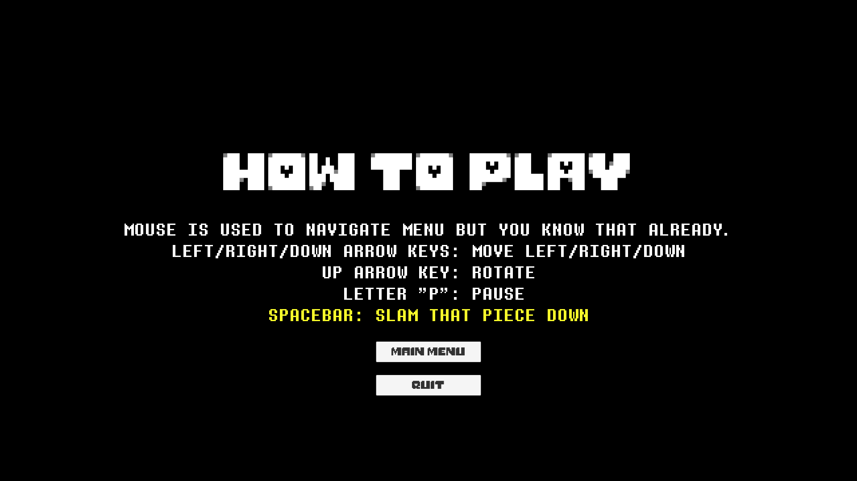

## HUD

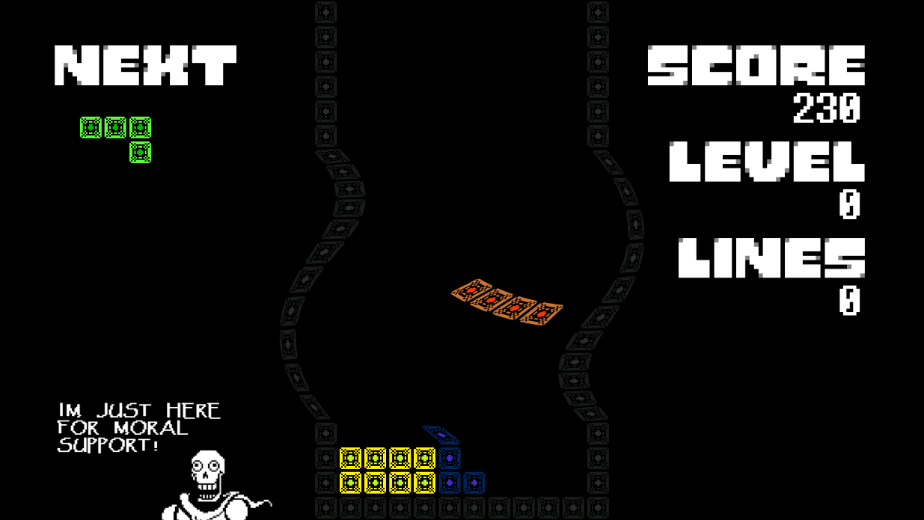

**NEXT:** The puzzle piece that is to be upcoming.

**SCORE:** The Player’s score.

**LEVEL:** The Player’s current level.

**LINES:** The amount of lines cleared by the Player.

# Players

## Characters

The Player is not present, just the controller. A skeleton named “Papyrus” accompanies you in your adventure to eliminate horizontal lines. The puzzle pieces are a total of seven which include:

1. Square
2. Line
3. S-Shaped
4. Z-Shaped
5. L-Shaped
6. J-Shaped
7. T-Shaped

## Metrics

**Clear 1 line:** 100 + (Level * 25)

**Clear 2 lines:** 400 + (Level * 50)

**Clear 3 lines:** 800 + (Level * 75)

**Clear 4 lines (Tetris):** 1600 + (Level * 100)

**Drop Speed:** 1 second – (Level * 0.1)

# Art

## Setting

The game takes place in the black abyss with a grid laid out for the Player.

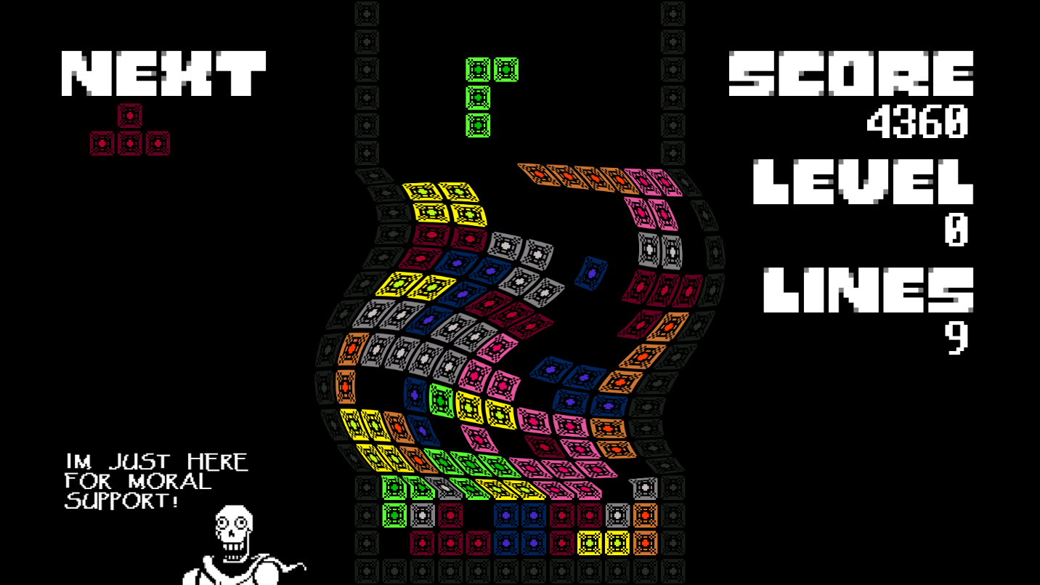

## Level Design

The level consists of puzzle pieces being amounted on the screen by the Player with a warped screen. The puzzle pieces will be spawned from the top and be placed towards the bottom of the play area.

## Audio

|  |  |  |
| --- | --- | --- |
| Name | Category | Description |
| Undertale - Dating Start!.wav | Main Menu Music | Plays only at Main Menu |
| Undertale - Bonetrousle.wav | Play Music | Plays during the game |
| land.wav | FX | Puzzle piece reaches the bottom |
| linecleared.wav | FX | Horizontal line made |
| move.wav | FX | Moving the puzzle piece |
| rotate.wav | FX | Rotating the puzzle piece |

# What you Developed

The aesthetic of the game, coding the entirety of it, puzzle pieces assets.

# Credits

Capcom - Megaman Land sound

Konami - Wow! sound

Square Enix - FF7 select/ready sounds

The Weekly Coder - Code help

Toby Fox - Papyrus character, fonts, music

# Development Log

11/14/2017

Initial Commit

11/14/2017

Development Log

11/21/2017

Art assets added

- Art blocks added, working on unity file merge to repo

11/23/2017

Unity Folder merged

11/23/2017

Tetrimino prefabs created

11/23/2017

User input, prefab instantiation, boundary placed

- Game functions to a slight degree, this includes, the boundaries

holding the puzzle pieces in, the puzzle pieces falling down and

when they reach the bottom, a new prefab is instantiated.

- Next update will include the row clear and bringing all objects above down 1 row.

11/24/2017

Game mechanics complete!

- Game functions as normal, but needs more to function on a "happy good" level.

11/25/2017

Score, Sound added

11/25/2017

Main menu, Game Over menu, Level Difficulty added, UI/UX enhanced

- Implemented Score, Level, Lines communication to the user via HUD

as well as knowing what the next piece is. Added a slider for difficulty.

11/25/2017

High score, fonts, quit function, gameplay dynamic changed

- Put high score feat on main menu scene, fonts added, still need to update all

text figures, quit function implemented for build so one can safely exit

the application, added a "twirl" effect to the grid to create gameplay

dynamic to be more difficult.

11/26/2017

Scenes finished, controls optimized, nearly complete

- Everything is accounted for such as loading scenes, controls favoring user

experience, and aesthetic of the overall interface. Future update will

include more of my assets.

11/26/2017

Game completed!

- Everything works in order on a PC build, will be pushing the extra things such

as documentation soon. Very proud of what I've made.

- Things fixed included: Music playing correctly in the correct scenes, my own

assets being made in order to fulfill Graphics Category, secret pause dialogue.